

NAME: ABDUL SAMI
CASTE : WADHO

ORACLE ERP DEVELOPER

INSTITUTE OF MATHEMATICS & COMPUTER SCIENCE

ABSTRACT

To digitize our daily routine, work the salon management system is organize the salon sales and production with customers, SMS incorporate daily customers with different categories cutting, curling, coloring and arranging the hair, for both man and women’s. Including purchase of salon goods and utilization for customers. Helps to serve customers better and keep them coming back by providing salon information such as what are services, let the customer know the location, customer rating, how much experience employees have and prices of salon menu etc. We go to the salon there is crowed like a lot of people sit for their round, and here is time wasting of customer so, without Salon Management System (SMS) we face many difficulties
Customers don’t know what are services the salon provides.
Customers don’t know the charges.
Customers don’t know the rating for each barber.

Function of SMS.
High to Low rated salon Location.
Procedure to treat customers.
service.
Barber experience.
Equipment and Cleaning care.
Payment service.

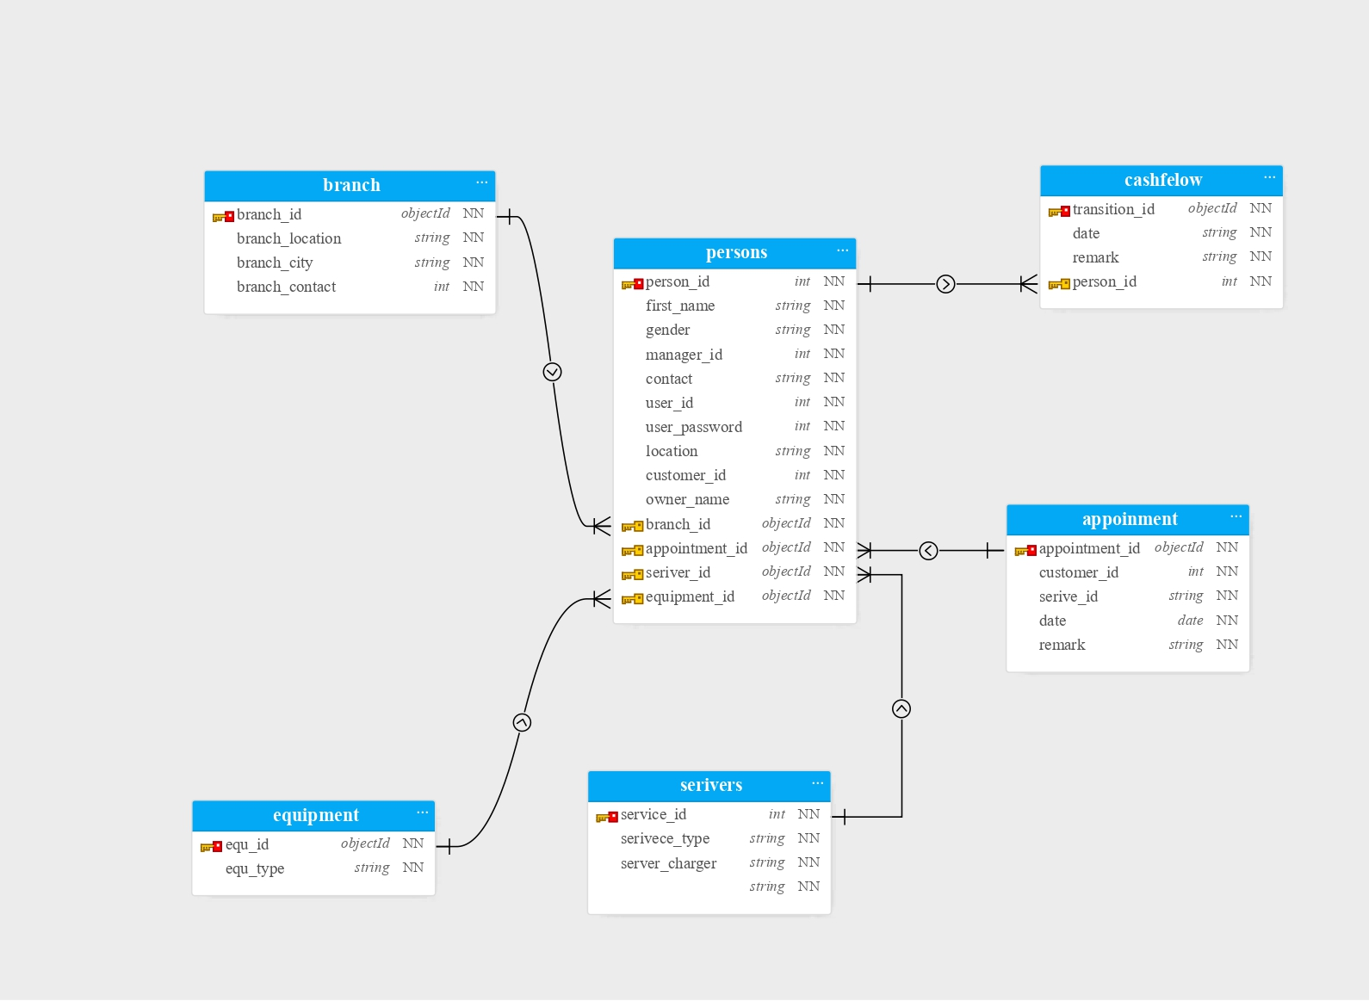

(PERFORMING DDL)

create table account(user_id varchar2(50),user_password varchar2(50));
insert into account(user_id,user_password)
values('sabir ','wadho');
------------------------------------------
equipment
create table equipment(equ_id varchar2(50),product_type varchar2(50),service_id varchar2(50),constraint equ_id_pk primary key(equ_id));

ALTER TABLE equipment
ADD CONSTRAINT equipment_service_fk
FOREIGN KEY(service_id)
REFERENCES equipment(EQU_ID);

-----------------------------------------
bill_voucher
create table bill_voucher(serial_no varchar2(50),payment_method varchar2(30),
description varchar2(40),amount number(7), constraint serial_no_pk primary key(serial_no) );

------------------------------------------------
branch
create table branch(branch_id varchar2(50),branch_city varchar2(50),branch_location varchar2(50),
branch_contact varchar2(50), constraint branch_id_pk primary key(branch_id));

-------------------------------------
service
create table service(service_id varchar2(50),service_type varchar2(50),service_charge number(7),
constraint service_id_pk primary key(service_id));

-------------------------
customers

create table customers(customer_id varchar2(50) not null,service_id varchar2(50) not null,
appointment_id number(7) not null,appointment_date date default systimestamp,
constraint customer_id_pk primary key(customer_id));
ALTER TABLE customers
ADD CONSTRAINT customer_service_fk
FOREIGN KEY(service_id)
REFERENCES customers(customer_id);

for seeing forgin key
SELECT constraint_name, column_name
FROM user_cons_columns;

---------------------------

create table Persons(
person_id varchar2(50) not null ,branch_id varchar2(50) not null,
first_name varchar2(50) not null , gender varchar2(7) not null ,
manager_id varchar2(50) , contact varchar2(15)) ,
user_id varchar2(50),user_password varchar2(14) ,
owner_name varchar2(50) ,customer_id varchar2(50),service_id varchar2(50),
equ_id varchar2(50),serial_no varchar2(50),
constraint Person_id_fk primary key(person_id),
CONSTRAINT Persons_branch_fk FOREIGN KEY (branch_id) REFERENCES branch(branch_id),
CONSTRAINT Persons_customer_fk FOREIGN KEY (customer_id) REFERENCES customers(customer_id),
CONSTRAINT Persons_service_fk FOREIGN KEY (service_id) REFERENCES service(service_id),
CONSTRAINT Persons_equipment_fk FOREIGN KEY (equ_id) REFERENCES equipment(equ_id),
CONSTRAINT Persons_bill_voucher_fk FOREIGN KEY (serial_no) REFERENCES bill_voucher(serial_no));

-----------------------OR--------------------------------------------------------------
ALTER TABLE AHMED
ADD CHECK (GENDER='MALE,FEMALE');
------------------------------------------------------------------------------------------------------------|

1)CREATE TABLE---------------- |
create table time(birth date); |
|
2)INSERT DATA ---------------- |
insert into time |
values(to_date('1998/05/31:12:40:00AM', 'yyyy/mm/dd:hh:mi:ssam')); |
|
FOR DAY TO YEAR------------------ |
3)select TO_CHAR(SYSDATE,'FMDD MONTH YYYY') |
from TIME; |
|
FOR TIME ---------------------------- |
4)Select to_char(birth,'HH24:MI:SS AM') from time; |
|
FOR BOTH DD TO YEAR AND TIME-------------------- |
select to_char(sysdate, 'Dy DD-Mon-YYYY HH24:MI:SS') as "Current Time" |
from TIME; |
----------------------------------------------------------------------------------------------------------- |

( PERFORMING DML )

DESC BRANCH
SELECT* FROM BRANCH;
insert into BRANCH values('B_101','LARKANA','1700','03111111815');
insert into BRANCH values('B_102','QUETTA','1702','03111111715');
insert into BRANCH values('B_103','JAMSHORO','1703','03111111215');
insert into BRANCH values('B_104','SUKKER','1704','03111111415');
insert into BRANCH values('B_105','SIALKOT','1705','03111111315');
insert into BRANCH values('B_106','KARACHI','1706','03111111115');
insert into BRANCH values('B_107','QUETTA','1707','03111111515');
insert into BRANCH values('B_108','QAMBER','1708','03111111915');
insert into BRANCH values('B_109','TANDO ADAM','1709','03111111615');
insert into BRANCH values('B_110','JACOBABAD','1710','03111112015');
insert into BRANCH values('B_111','KOHAT','1711','03111114515');
-------------------------------------------------------------------------------------
SERVICE
Desc service;
select * from service;
insert into service(service_id ,service_type ,service_charge)
VALUES('S_1', 'Moustache and Beard Trim',300);
insert into service VALUES('S_2','Hair and Scalp Treatments',400);
insert into service VALUES('S_3','Shampoo, Cut, Style, Blow-dry',550);
insert into service VALUES('S_4','Laser Hair Removal',800);
insert into service VALUES('S_5','Moustache Trim',150);
insert into service VALUES('S_6','Hair Style and Stately Shave',250);
insert into service VALUES('S_7','Stately Shave (Hot towels, Balm)',600);
insert into service VALUES('S_8','Natural Nail Grooming',3500);
insert into service VALUES('S_9','Massage',1500);
insert into service VALUES('S_10','Hair color',450);

ALTER TABLE equipment
ADD service_id varchar2(50);

INSERT INTO equipment(equ_id ,product_type ,service_id)
VALUES('EQ_11','TRIMER,Barber Straight Razor','S_1');
INSERT INTO equipment VALUES('EQ_22','Coconut oil,Mashed bananas','S_2');
INSERT INTO equipment VALUES('EQ_33','Barber Scissorss,Hairdryer','S_3');
INSERT INTO equipment VALUES('EQ_44','laser hair removal','S_4');
INSERT INTO equipment VALUES('EQ_55','TRIMER','S_5');
INSERT INTO equipment VALUES('EQ_66','Straight razor,shaving brush','S_6');
INSERT INTO equipment VALUES('EQ_77','TRIMER,Barber Straight Razor','S_7');
INSERT INTO equipment VALUES('EQ_88','Terra Beauty Bars Nail Polish','S_8');
INSERT INTO equipment VALUES('EQ_99','Coconut Oil,Massage','S_9');
INSERT INTO equipment VALUES('EQ_110','Hair Colors,Shampoos','S_10');

insert into bill_voucher(serial_no ,payment_method,description ,amount )
values('SNO_10111','Credit','Good Service',300);
insert into bill_voucher values('SNO_10112','Credit','Excellent Service',400);
insert into bill_voucher values('SNO_10113','Debit','Excellent Service',550);
insert into bill_voucher values('SNO_10114','Credit','Good Service',800);
insert into bill_voucher values('SNO_10115','Debit','Excellent Service',150);
insert into bill_voucher values('SNO_10116','Debit','bad Service',250);
insert into bill_voucher values('SNO_10117','Debit','Good Service',600);
insert into bill_voucher values('SNO_10118','Credit','Good Service',3500);
insert into bill_voucher values('SNO_10119','Credit','Excellent Service',1500);
insert into bill_voucher values('SNO_10120','Debit','Good Service',450);

insert into customers values('C_1001','S_4',79061,to_date('2020/07/15:01:40:00PM','yyyy/mm/dd:hh:mi:ssam'));
insert into customers values('C_1002','S_5',79062,to_date('2020/07/15:06:33:00AM','yyyy/mm/dd:hh:mi:ssam'));

insert into customers values('C_1003','S_2',79063,to_date('2020/07/15:07:23:00PM','yyyy/mm/dd:hh:mi:ssam'));

insert into customers values('C_1004','S_4',79064,to_date('2020/07/15:01:15:20PM','yyyy/mm/dd:hh:mi:ssam'));

insert into customers values('C_1005','S_8',79065,to_date('2020/07/15:01:15:00PM','yyyy/mm/dd:hh:mi:ssam'));

insert into customers values('C_1006','S_7',79066,to_date('2020/07/15:11:59:10PM','yyyy/mm/dd:hh:mi:ssam'));

insert into customers values('C_1007','S_2',79067,to_date('2020/07/15:07:51:05PM','yyyy/mm/dd:hh:mi:ssam'));

insert into customers values('C_1008','S_10',79068,to_date('2020/07/15:02:30:40PM','yyyy/mm/dd:hh:mi:ssam'));

insert into customers values('C_1009','S_1',79069,to_date('2020/07/15:10:25:28AM','yyyy/mm/dd:hh:mi:ssam'));

insert into customers values('C_1010','S_8',79070,to_date('2020/07/15:10:28:19AM','yyyy/mm/dd:hh:mi:ssam'));

INSERT INTO PERSONS VALUES('P_10111EMP','B_101','SABIR','MALE',982091,03333324555,'sabir','wadho','ABDULSAMED','C_1001','S_1','EQ_11','SNO_10111');
Insert into persons VALUES('P_10112EMP','B_102','SAMI','MALE',982092,03332283535,'sami','wadho','ABDULSAMED','C_1002','S_2','EQ_22','SNO_10112');
Insert into persons VALUES('P_10113EMP','B_103','SADIQUE','MALE',982093,03339224535,'sadique','wadho','ABDULSAMED','C_1003','S_3','EQ_33','SNO_10113');
Insert into persons VALUES('P_10114EMP','B_104','AHAD','MALE',982094,0333209877,'ahad','wadho','ABDULSAMED','C_1004','S_4','EQ_44','SNO_10114');
Insert into persons VALUES('P_10115EMP','B_105','ASIF','MALE',982095,033322324654,'asif','hakro','ABDULSAMED','C_1005','S_5','EQ_55','SNO_10115');
Insert into persons VALUES('P_10116EMP','B_106','ALI','MALE',982096,033787644535,'ali','memon','ABDULSAMED','C_1006','S_6','EQ_66','SNO_10116');
Insert into persons VALUES('P_10117EMP','B_107','HIRA','FEMALE',982097,03332237735,'hira','pathan','ABDULSAMED','C_1007','S_7','EQ_77','SNO_10117');
Insert into persons VALUES('P_10118EMP','B_108','ZAHID','MALE',982098,033326824535,'zahid','hakro','ABDULSAMED','C_1008','S_8','EQ_88','SNO_10118');
Insert into persons VALUES('P_10119EMP','B_109','AHMED','MALE',982099,033323424535,'ahmed','soomro','ABDULSAMED','C_1009','S_9','EQ_99','SNO_10119');
Insert into persons VALUES('P_10120EMP','B_110','FERHAN','MALE',982100,03332254535,'ferhan','memon','ABDULSAMED','C_1010','S_10','EQ_110','SNO_10120');Insert into persons VALUES('P_10112EMP','B_102',’SAMI','MALE',982092,03332283535,’sami’,'wadho','ABDULSAMED','C_1002','S_2','EQ_22',SNO_10112);
Insert into persons VALUES('P_10113EMP','B_103',’SADIQUE,'MALE',982093,03332224535,’sadique,'wadho','ABDULSAMED','C_1003','S_3','EQ_33',SNO_10113);
Insert into persons VALUES('P_10114EMP','B_104',’AHAD,'MALE',982094,033209877,ahad,'wadho','ABDULSAMED','C_1004','S_4','EQ_44',SNO_10114);
Insert into persons VALUES('P_10115EMP','B_105',’ASIF','MALE',982095,0332324654,’asif’,'hakro','ABDULSAMED','C_1005','S_5','EQ_55',SNO_10115);
Insert into persons VALUES('P_10116EMP','B_106',’ALI','MALE',982096,033787624535,’sami’,'memon','ABDULSAMED','C_1006','S_6','EQ_66',SNO_10116);
Insert into persons VALUES('P_10117EMP','B_107',’HIRA','FEMALE',982097,033322378735,’hira’,'pathan','ABDULSAMED','C_1007','S_7','EQ_77',SNO_10117);
Insert into persons VALUES('P_10118EMP','B_108',’ZAHID','MALE',982098,03326824535,’zahid’,'hakro','ABDULSAMED','C_1008','S_8','EQ_88',SNO_10118);
Insert into persons VALUES('P_10119EMP','B_109',’AHMED','MALE',982099,03323424535,’ahmed’,'soomro','ABDULSAMED','C_1009','S_9','EQ_99',SNO_10119);
Insert into persons VALUES('P_10120EMP','B_110',’FERHAN','MALE',982100,033322524535,’ferhan’,'memon','ABDULSAMED','C_1010','S_10','EQ_110',SNO_10120);

